**Shell scripting:**

#!/bin/bash --- should be in first line.

echo {}

-e enable esc sequence :

\n new line

\t new tab

\e new color

whenever you use -e option in echo command provide i/p in "" quotes.

ex: echo -e "Hi\nBye"

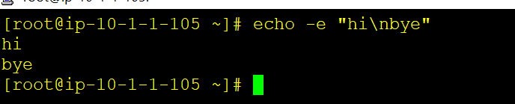

===========================================================================================

#!/bin/bash

#This script is to create new users and auto generated password

read -p "Please enter the user name: " user_name

#user_name=${@} we need to use forloops to exec this using param

users={@}

special='!@#$%^&*()_+'

special_char=$(echo $special| fold -w1|shuf|head -1)

PASSWORD=$(date +%s)${RANDOM}${special_char}

useradd ${user_name} -p ${PASSWORD}

echo

echo ${user_name}created successfully and password is ${PASSWORD}

echo 'Thank you Have a Good Day'

============================================================================================

#!/bin/bash

#script to create multiple users by taking o/p params

users=${@}

for user in ${users}

do

spec='!@#$%^&*()_+'

spec_char=$(echo $spec|fold -w1|head -1)

password=$(date +%s)${RANDOM}${spec_char}

useradd $user -p ${password}

echo "${user} has created created successfully and password is ${password}"

done

===============================================================================================